Calculative Foundation

Part A — Vector & Matrix Fundamentals
In this dataset, each student's scores across Math, Physics, and Chemistry form a vector in 3-dimensional space, and the full set of students forms a matrix. The concepts below describe how such vectors are measured, compared, and combined.

A1. Vector Representation
Definition: A vector is an ordered list of numbers that represents both a magnitude and a direction in space. Each component corresponds to one feature or dimension.
Student vector: S = [Math, Physics, Chemistry] e.g. S1 = [85, 90, 78]

A2. Vector Norms
Definition: A norm is a function that measures the "size" or length of a vector.
- Norm-1 (Manhattan norm): the sum of the absolute values of the components — like measuring distance by moving only along grid lines.
- Norm-2 (Euclidean norm): the straight-line ("as the crow flies") length of the vector, computed via the Pythagorean theorem.
||x||₁ = |x1| + |x2| + |x3| ||x||₂ = sqrt(x1^2 + x2^2 + x3^2)
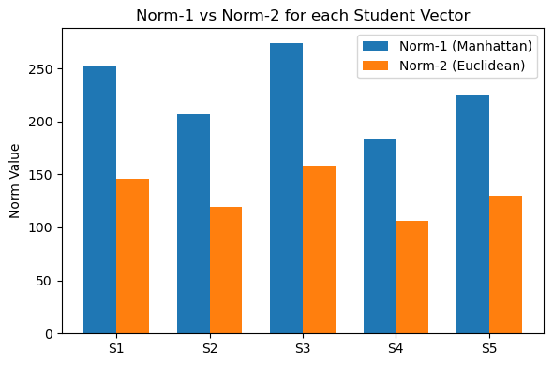
Norm-1 vs Norm-2 for each student, computed from actual notebook output.

A3. Dot Product and Angle Between Vectors
Definition: The dot product multiplies corresponding components of two vectors and sums the results. It measures how much two vectors point in the same direction, and is the basis for computing the angle between them.
a.b = a1*b1 + a2*b2 + a3*b3 cos(theta) = (a.b) / (||a|| . ||b||)
A small angle (cos(theta) close to 1) means the two students have a similar performance pattern across subjects; a larger angle means their strengths differ more.
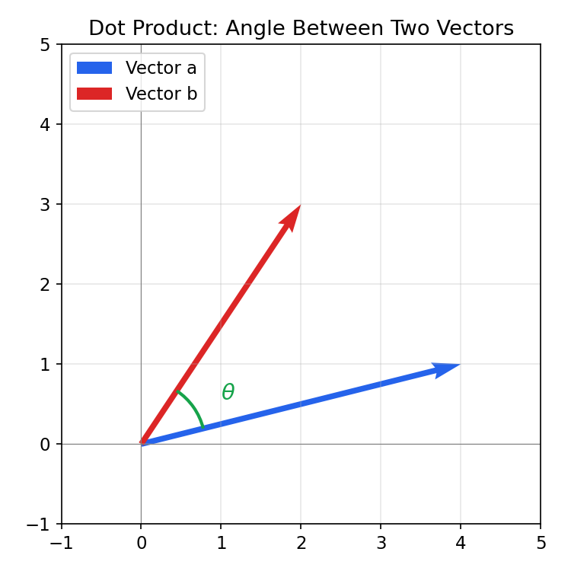
The angle theta between two vectors, derived from their dot product.

A4. Cross Product
Definition: The cross product of two 3D vectors produces a new vector that is perpendicular (orthogonal) to both original vectors. Its magnitude relates to the area of the parallelogram the two vectors span.
a x b = [ a2*b3 - a3*b2, a3*b1 - a1*b3, a1*b2 - a2*b1 ]
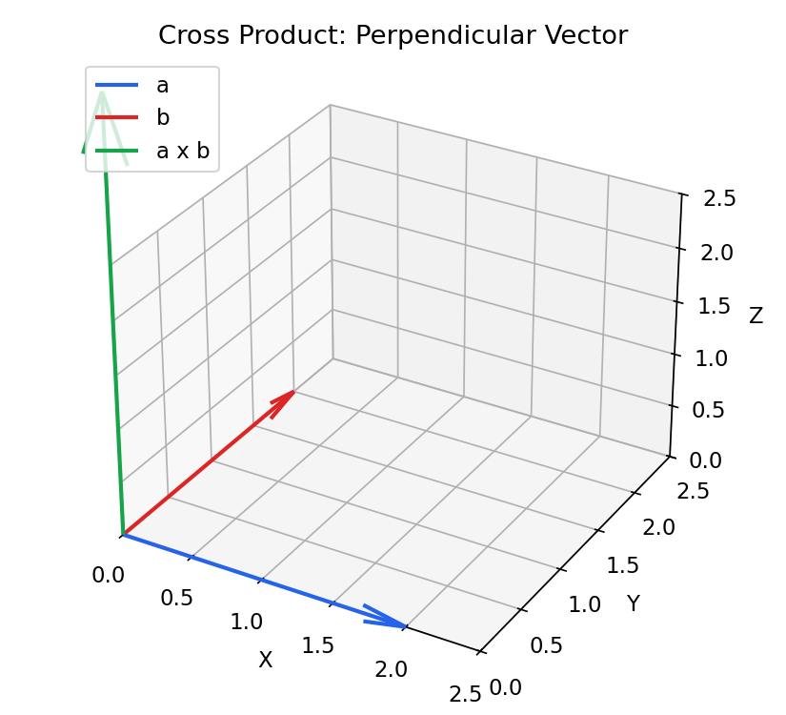
The cross product a x b is perpendicular to both a and b.

A5. Vector Projection
Definition: The projection of vector a onto vector b is the "shadow" that a casts onto the line defined by b — the component of a that lies in the direction of b.
proj_b(a) = [ (a.b) / ||b||^2 ] . b
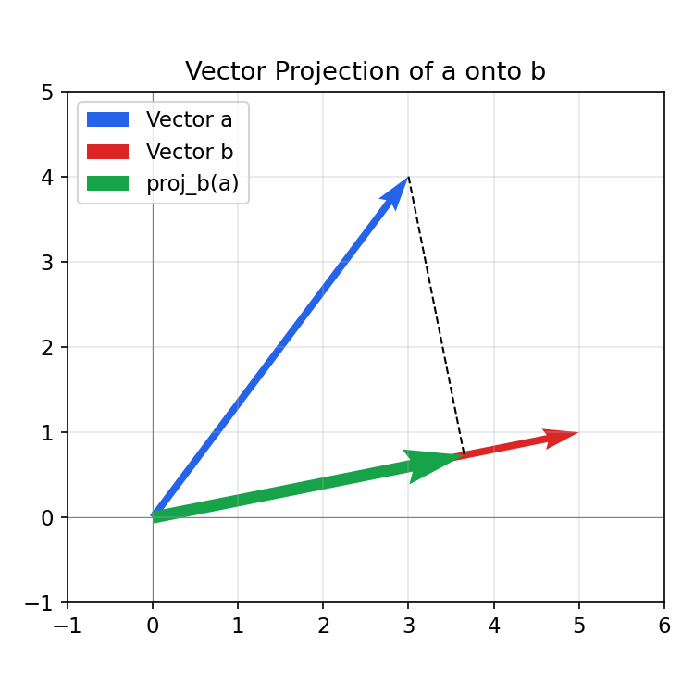
Projection of vector a onto vector b (dashed line shows the perpendicular drop).

Part B — Matrix Operations
Once individual student vectors are stacked together, they form a matrix — here, a Students x Subjects matrix. Matrix operations let us transform, combine, and analyze this data as a whole.

B1. Matrix Addition and Multiplication
Definition: Matrix addition combines two matrices of the same shape by adding corresponding entries (e.g., adding bonus marks to every score). Matrix multiplication combines rows of one matrix with columns of another using dot products — used here to compute a single weighted total score per student from subject weights.
(A + B)ij = Aij + Bij (M . w)i = sum over j of ( Mij . wj )

B2. Transpose
Definition: The transpose of a matrix flips it over its diagonal, turning rows into columns and columns into rows. A Students x Subjects matrix becomes a Subjects x Students matrix.
(M^T)ij = Mji

B3. Determinant and Inverse
Definition: The determinant is a single number computed from a square matrix that indicates whether the matrix can be "undone" (inverted) — a non-zero determinant means an inverse exists. The inverse of a matrix M is the matrix M^-1 such that multiplying them together gives the identity matrix, effectively reversing the transformation M represents.
M . M^-1 = I (defined only when det(M) is not zero)

Part C — Linear Transformations & Geometry

C1. Line, Plane, and Hyperplane
Definition: These terms describe the geometric space that data occupies as more features (dimensions) are added.
- Line (1D): with only one subject (e.g. Math), each student is a single point on a number line.
- Plane (2D): with two subjects (Math, Physics), each student becomes an (x, y) point on a flat plane.
- Hyperplane (n-1 D): a flat subspace one dimension smaller than the full space, which divides that space into two parts — a line is a hyperplane in 2D, and a plane is a hyperplane in 3D.

C2. Dimensionality Increase
Definition: As more subjects (features) are added to the dataset, the space needed to represent each student grows by one dimension per feature.
- 1 subject -> 1D (a line)
- 2 subjects -> 2D (a plane)
- 3 subjects -> 3D (a space, where a plane acts as a hyperplane)
- 4+ subjects -> higher-dimensional space (cannot be visualized directly, but the same vector/matrix math still applies)
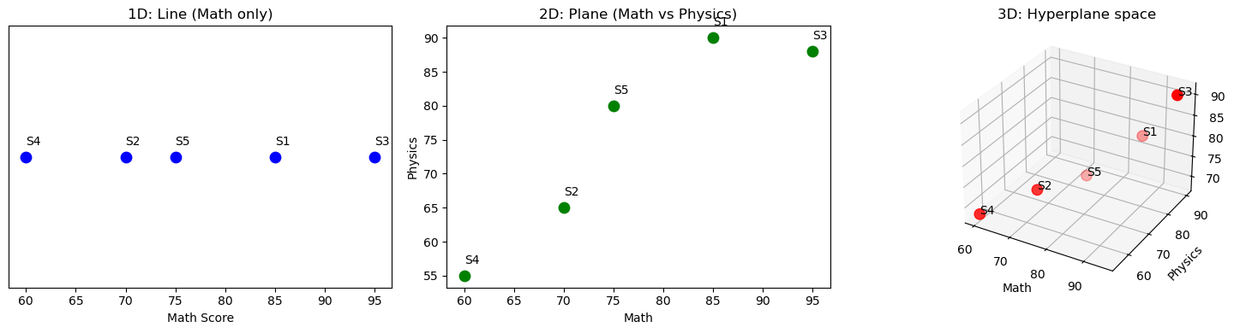
The same students plotted in 1D, 2D, and 3D as more subjects (dimensions) are added.

Part D — Eigenvalues & Decomposition

D1. Standardization and Covariance Matrix
Definition: Standardization rescales each subject so it has mean 0 and standard deviation 1, putting all subjects on a comparable scale. The covariance matrix then summarizes how each pair of subjects varies together — positive values mean subjects tend to rise and fall together.
z = (x - mu) / sigma Cov(X, Y) = E[ (X - mu_x)(Y - mu_y) ]

D2. Eigenvalues and Eigenvectors
Definition: For a square matrix A, an eigenvector is a special vector whose direction is unchanged when A is applied to it — it only gets stretched or shrunk. The amount of stretching is the corresponding eigenvalue.
A . v = lambda . v (v = eigenvector, lambda = eigenvalue)
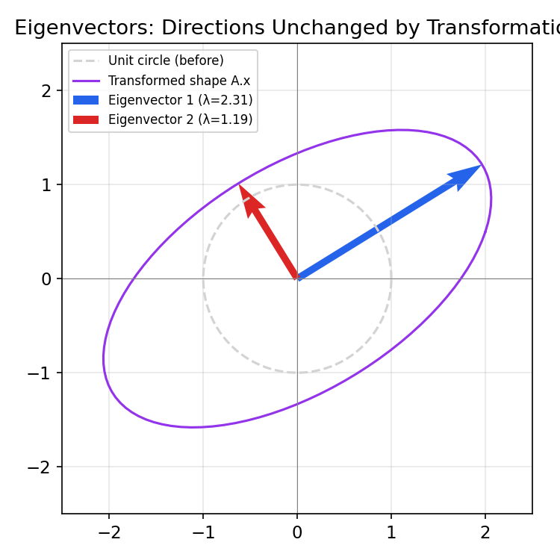
Eigenvectors of a transformation stay on the same line before and after transformation; the unit circle becomes an ellipse stretched along these directions.

D3. Principal Component Analysis (PCA) and Explained Variance
Definition: PCA uses the eigenvectors of the covariance matrix as new axes (principal components), ordered by how much variance (information) they capture. The explained variance ratio shows what percentage of the dataset's total spread each principal component accounts for.
Explained Variance % of PCi = ( lambda_i / sum of all lambda ) x 100
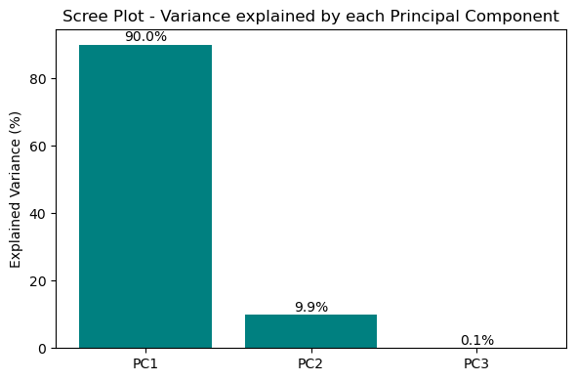
Scree plot: variance explained by each principal component, computed from the notebook output.

